JCARS DATASET
Data Cleaning
ID:
Capitalised the letters for uniformity. Then replaced the banks and N/A with ‘Not Provided
Customer type:
Corporate and company are 2 different things. A company is a broad, general term for any business entity engaged in commercial activity, including sole proprietorships and partnerships. A corporation is a highly specific, legally formalized type of company that is recognized as an independent legal entity, providing its owners (shareholders) with strict liability protection. A corporation is always a company, but not all companies are corporations.
Order and Delivery date:
Changed the data type to fit category. The numbers were also converted to a date format. Number represents a certain date from the starting point.
Age
Changed to appropriate data type. All the other errors were changed to null, including aged 121. There isn’t any record in the present time that someone got to that age. The oldest person ever recorded lived upto 122 years, in 1977.
Branch
Assumptions:
- Main Yard → Nairobi
- Mt Kenya → Central
- Ksm → Nyanza (or Kisumu depending on context)
Car Model
Kept all varierties of Golf ie GTI under golf. All LC ie prado, prado TX, under LC. This is genral beacsue there may be a TX, still under LC that one ay be refering to.
Car year
Year 1899 was given to 1999. There were no cars before
202A to null
Table to note when data cleaning data for sales:
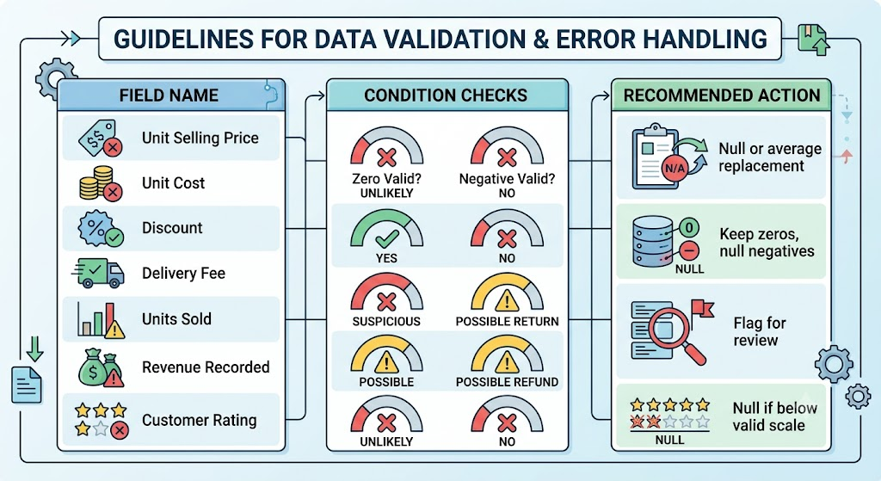
Discount
Anything above 100 and less than or equal to 0 was given as null.

